**Standard Operating Procedure, SOP**

**Titel:** **Cybi-Well vario**

**- Fix & Stain methods -**

**Valid: ERC Project**

**Author(s):** Thilo Miersch

*(Surname, Name)*

**Approved by:**

*(Surname, Name)*

**Staff Signature:**

*(signing below indicates that you have read this SOP and understand the material contained in it)*

|  |  |  |
| --- | --- | --- |
| **Date** | **Name** | **Signature** |
|  |  |  |
|  |  |  |
|  |  |  |
|  |  |  |
|  |  |  |
|  |  |  |
|  |  |  |
|  |  |  |

**Revision History**

|  |  |  |  |
| --- | --- | --- | --- |
| **Version** | **Reason for changes** | **Changed at** | **Changed from** |
| 02 | Corrected syntax erros | 06/2015 | Thilo |
| 03 | Installation of a second refill pump | 10/2015 | Thilo |
| 04 | Revised version | 03/2016 | Manuela |
|  |  |  |  |
|  |  |  |  |
|  |  |  |  |
|  |  |  |  |
|  |  |  |  |
|  |  |  |  |
|  |  |  |  |
|  |  |  |  |

**Table of contents**

1 Purpose 4

2 Description 4

2.1 Device designation 4

2.2 Located 4

2.3 Configuration and function 4

3 Materials & Reagents 5

4 Procedures 6

4.1 Activate Cybi-Well 6

4.2 Prime Cybi-Well 8

4.3 Fix cells with Fix-Perm-solution 8

4.4 Stain Cells with dye(s) & antibody 9

4.6 Clean Cybi-Well 10

4.7 Shut down Cybi-Well 10

5 Safety information 12

6 Other applicable documents 13

7 Attachements 13

7.1 Buffer 13

7.3 Fix and blocking solution 14

7.2 Stain solution 14

7.3 Clean and desinfect reagents 15

# 1 Purpose

This standard operation procedure ist to help to operate Cybio Cybiwell Vario workstation for fix and stain cell applications in 384 assay plates. The fixation and staining methods are limited to maximal 40 plates within 2 – 4 hours. The methods were developed for insect cells (Drosophila D.mel-2 cells) and human cells (Hek293T and HCT116).

The buffer and reagent concentrations are developed for D.mel-2 cells and have to be tested or adept for other cell lines.

# 2 Description

## 2.1 Device designation

384 Pipetting workstation with stacker and refillable reservoirs.

## 2.2 Located

Room 3.309

## 2.3 Configuration and function

* 384 tip head (changeable)
* Rail with 4 positions
* Quadstack for max. 4x40 plates
* 2x Refillable reservoir
* Washstation, deepwell
* 4x Masterflex pumps: No. 1 Fills up the washstation WS1

No. 2 Empties the washstation WS2

No. 3 Fills up the refillable reservoir RF1

No. 4 Fills up the refillable reservoir RF2

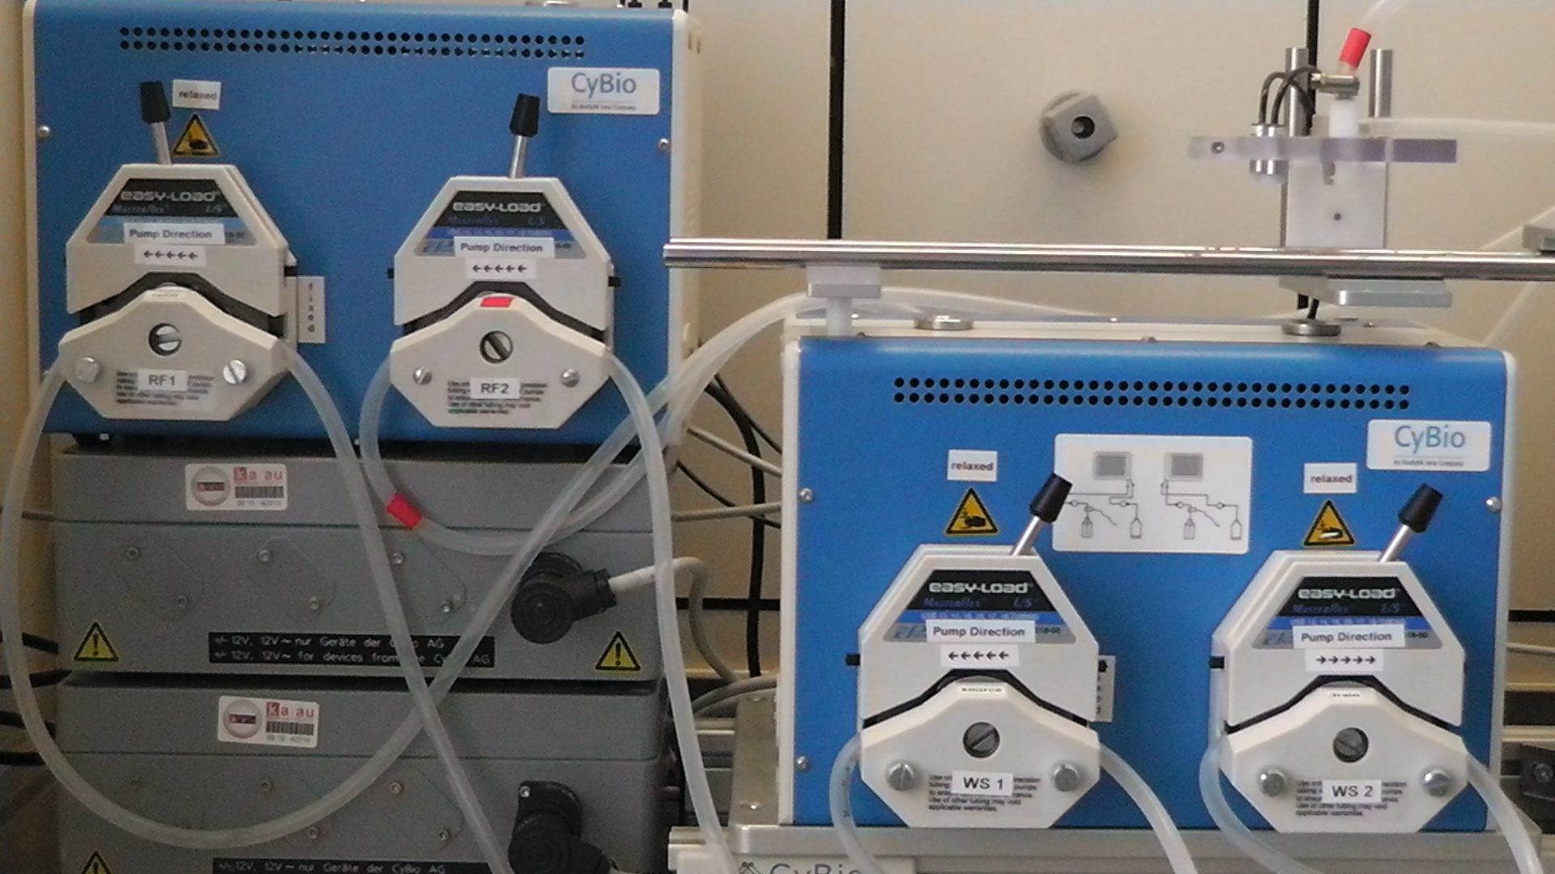

**3**

**4**

**2**

**1**

Figure 2-1: *Position of pump 1 – 4*

*HeidolphSteri-cup filtrieren.klar ist.*

# 3 Materials & Reagents

* 60µl 384er Tips; order number: OL3800-25-515-N Cybio
* 384er Shallow well; order number: 781280 Greiner bio-one
* BSA, *biotech quality* 1501.05 Gerbu
* FITC-a-Tubulin F2168-.5ml Sigma
* Hoechst 33342, 100mg H1399 Life Technologie
* Isopropanol, *technical* DKFZ-Lager
* KCl, p.A. 13096 DKFZ-Lager
* KH2HPO4 3904.1 Roth
* NaCl 13337 DKFZ-Lager
* Na2HPO4 P030.3 Roth
* Screw cap with olive PY86.1 Roth
* Steritop Millipore
* Sodiumhypochlorid Sigma-Aldrich
* PBS P3813-10PAK Sigma
* Paraformaldehyd 0335.3 Roth
* Phalloidin P1951 Sigma
* Pump-Tubings (replacement) 7,5m ISMCMF0318 VWR
* Triton X-100 X100-100ML Sigma
* Tween20 SA/P1379/000100 Th. Geyer
* Milliporewater DKFZ, R. 3.313

# 4 Procedures

**Notes:**

* For more informations on the instrument and Composer software, please ask the *responsable person (see black board Labjobs)*
* Preparation of buffers and solutions for fixation, staining and cleaning methods are described at the attachement
* Always use 384-well flat bottom shallow plates without a lid or alu seal!
* If a refillable reservoir is used, always calculate a dead volume of 50 ml
* Be aware that the system language is German

## 4.1 Activate Cybi-Well

**Note:** the following steps describe the procedure when Cybiwell is powered off.

1. Switch on PC, screen and Cybiwell *(put in the powerboard-plug in)*
2. Windows Log-in = **Admin**; password = **admin384**
3. Start **Cybio Composer** Software with a double klick at the desktop icon and choose **Script Studio**
4. Initialise Cybiwell: Push the enter button **„Weiter“** on the touchpad *(Figure 4-1)*. Is the tip magazine unloaded *(figure 4-1 to 4-5)* the message***„SPITZENWECHSEL“ Magazin einlegen (mit Spitzen)*** appears. Insert a new tip magazine and the message***„SPITZENWECHSEL Spitzen anziehen“*** appears. Confirm this message with the enter button (red).

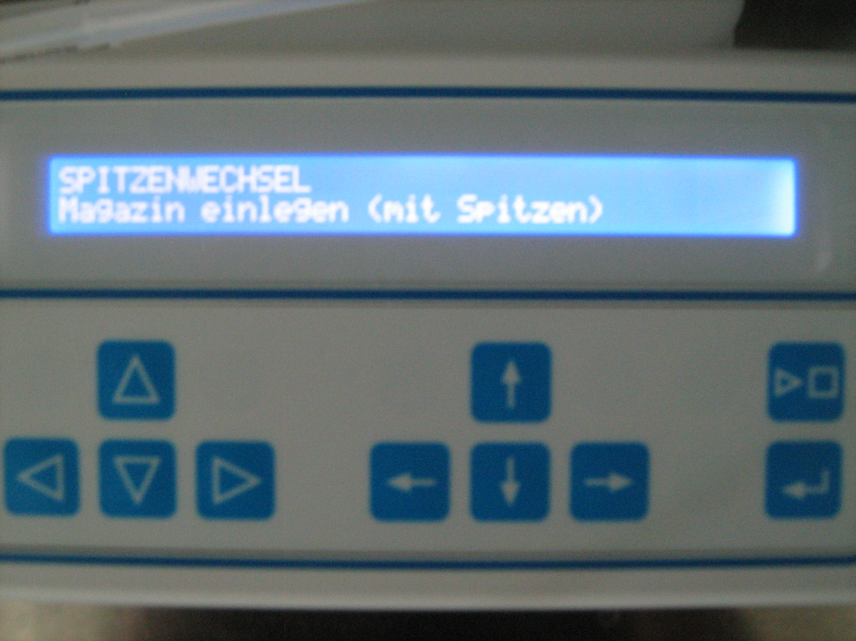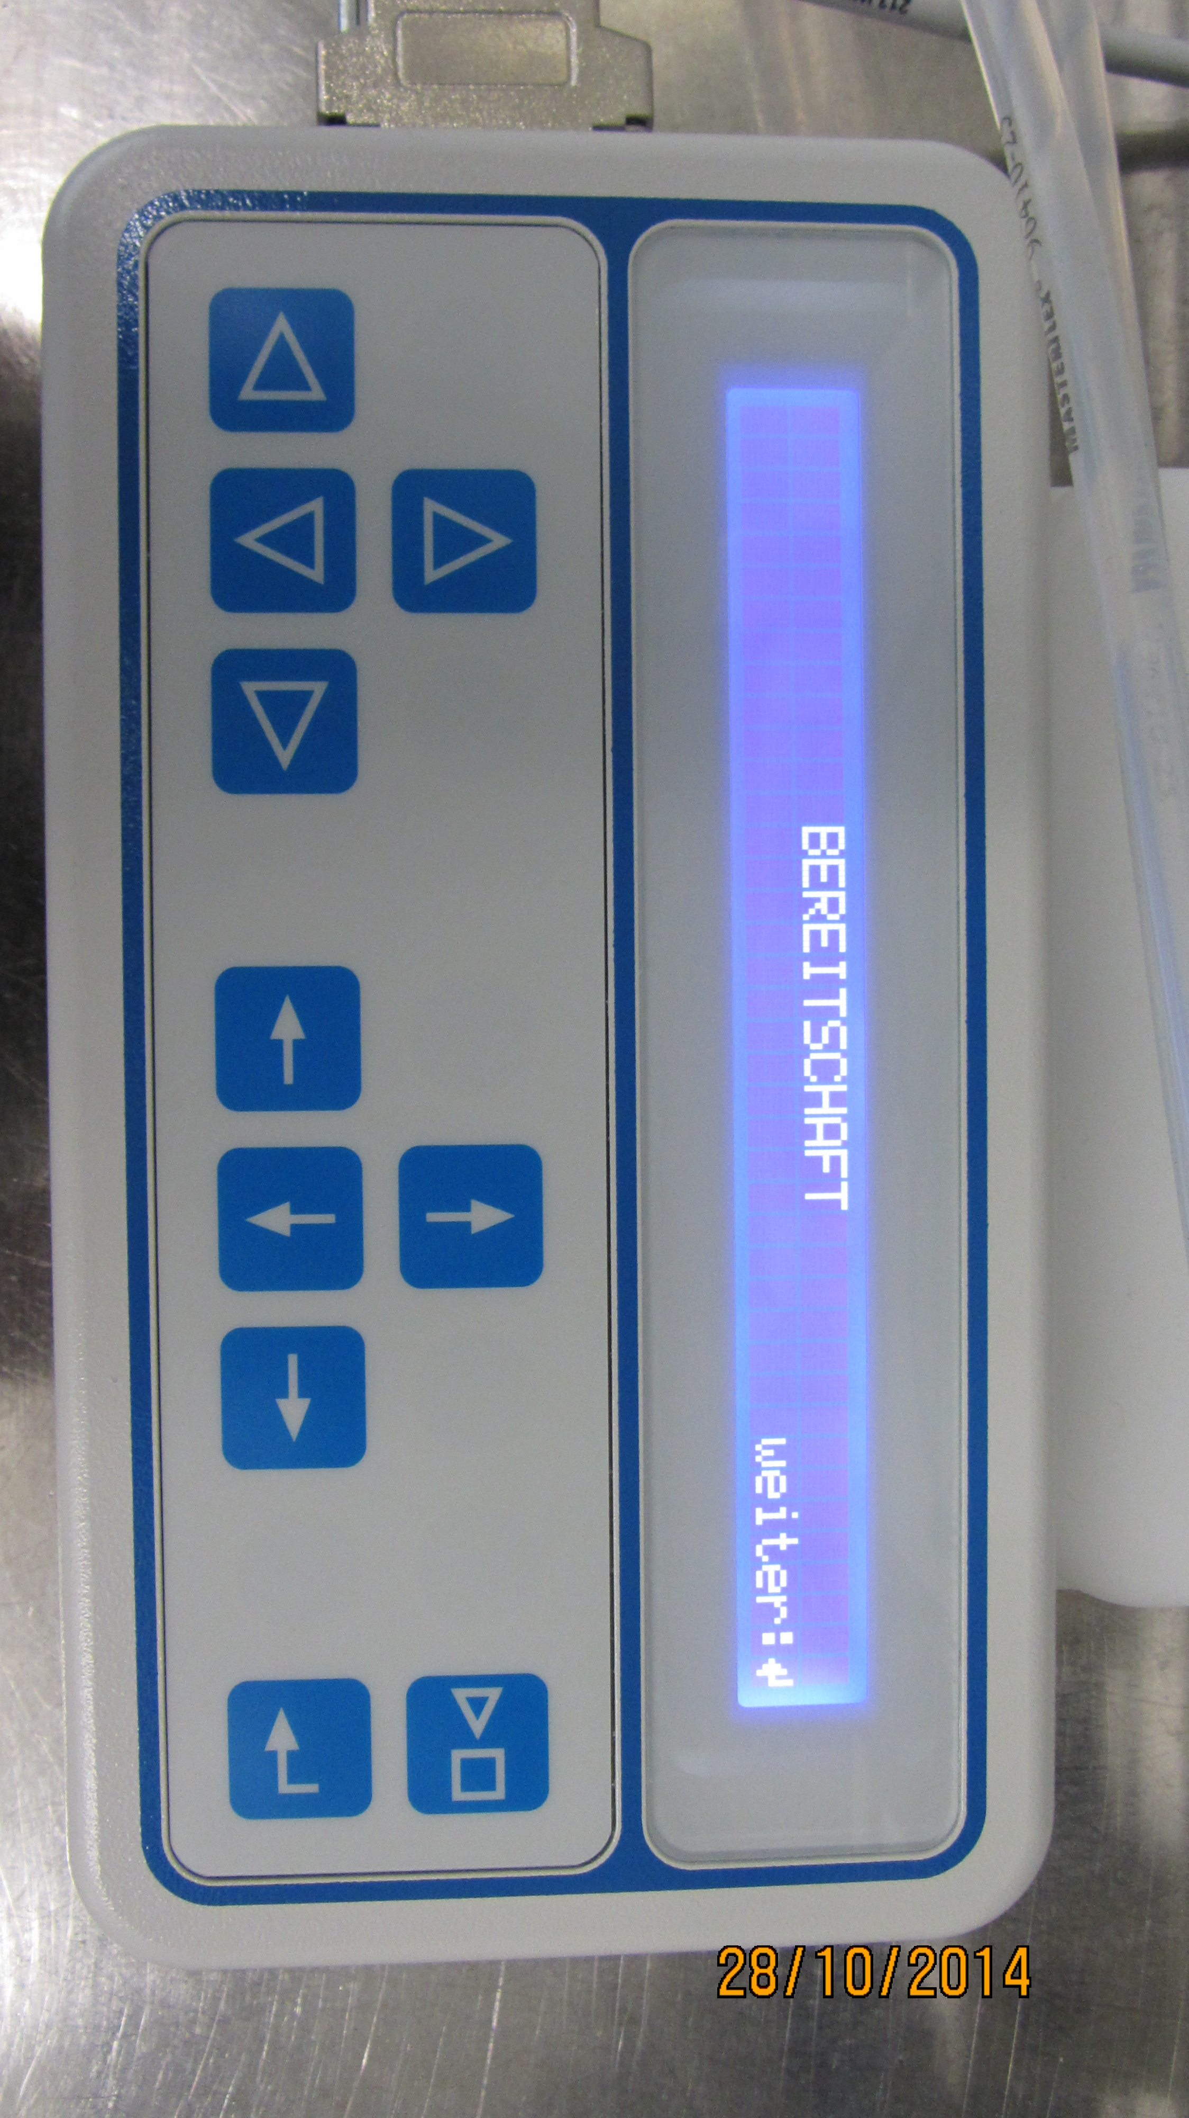

Figure 4-1: *Initialise Cybi-well* Figure 4-2: *Load tip-magazine*

*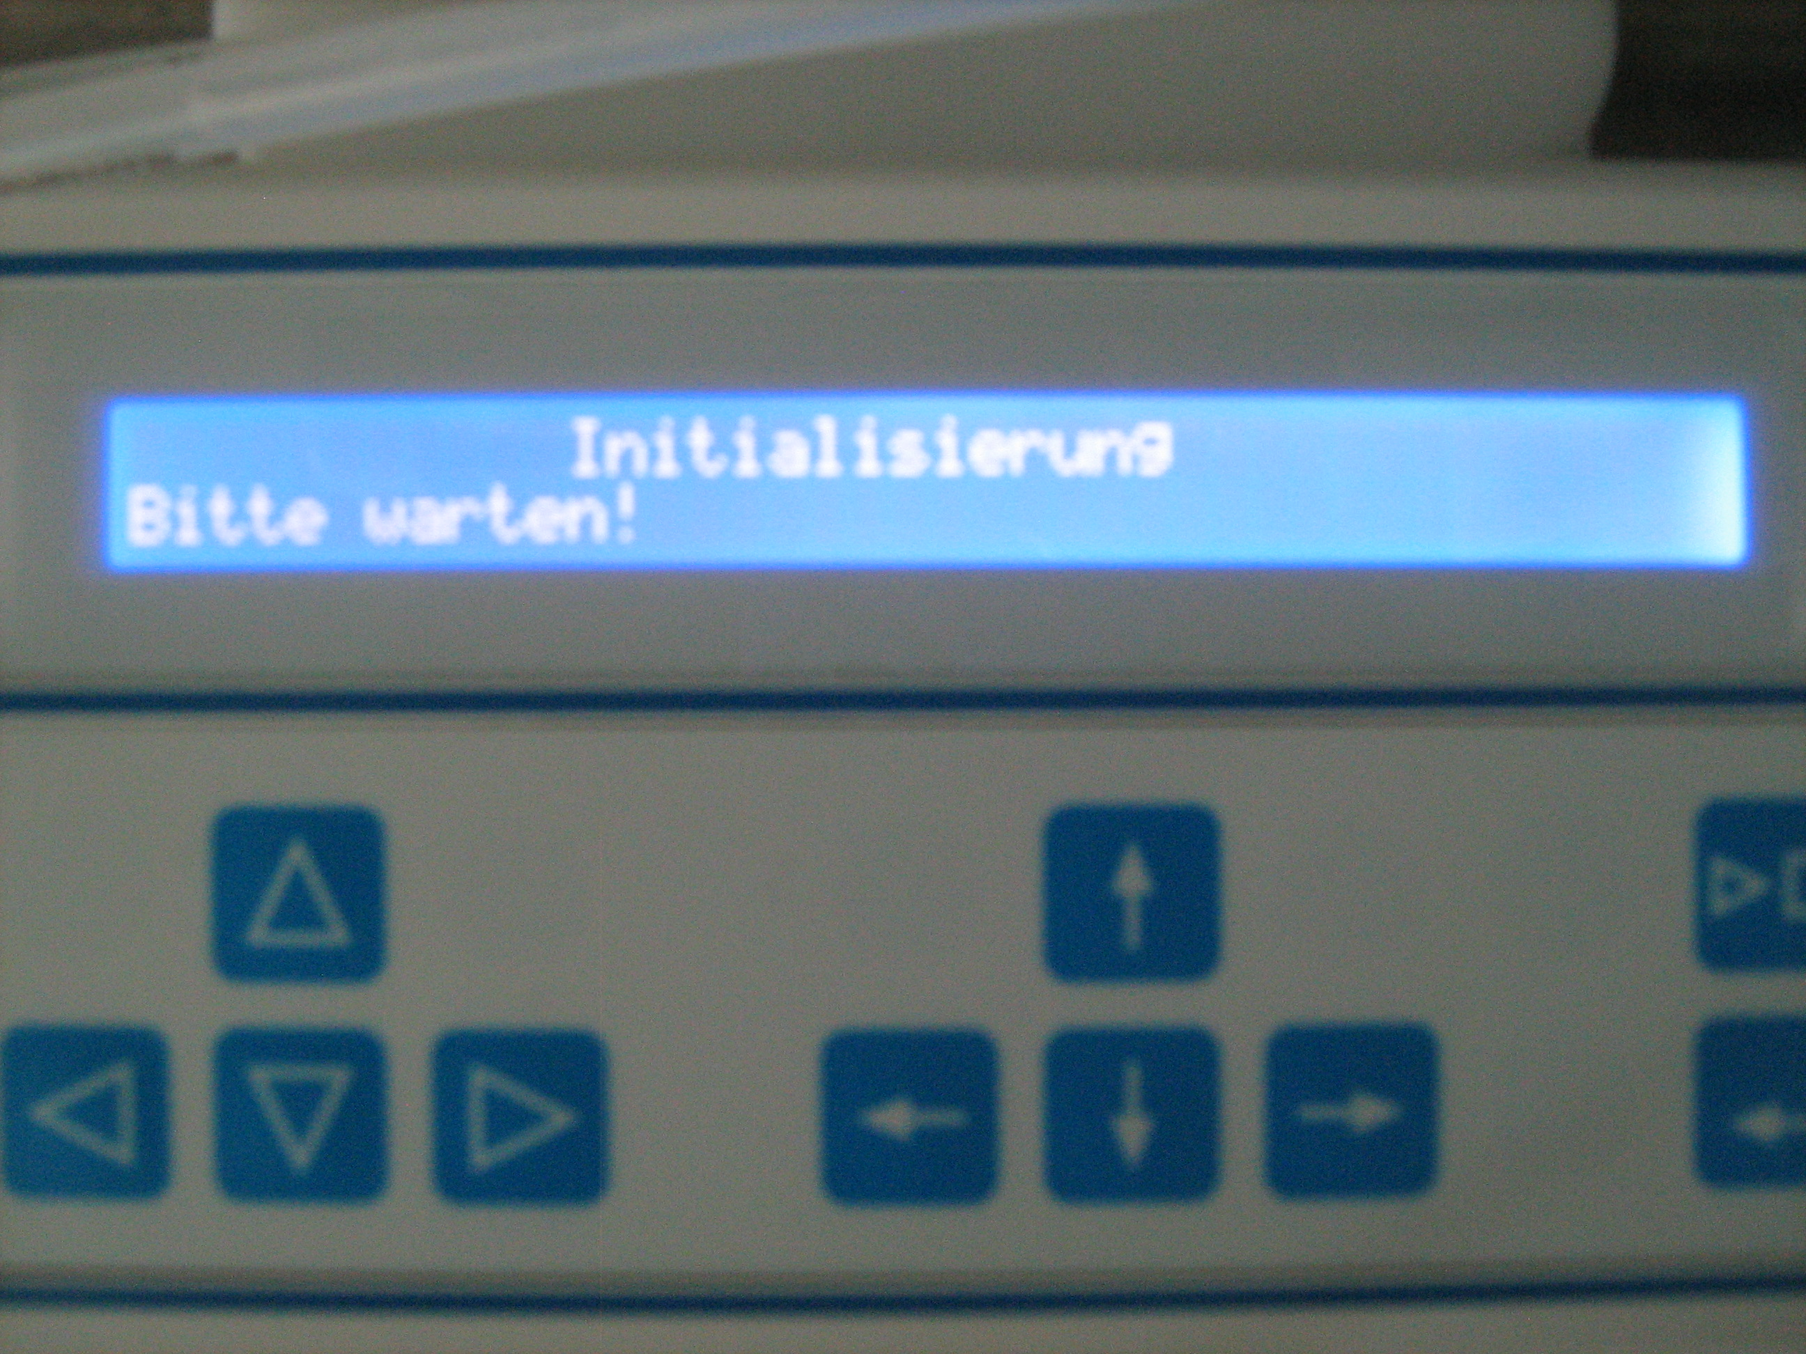*

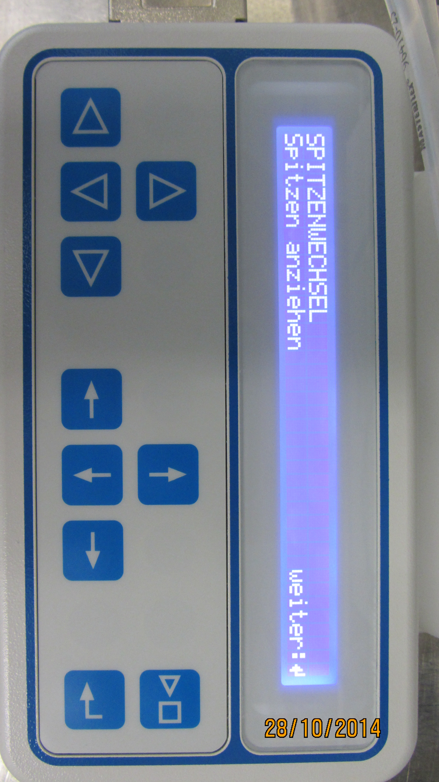

Figure 4-3: *Tipframe is loaded*, *press* ***weiter*** Figure 4-4: *Initialising is running*

*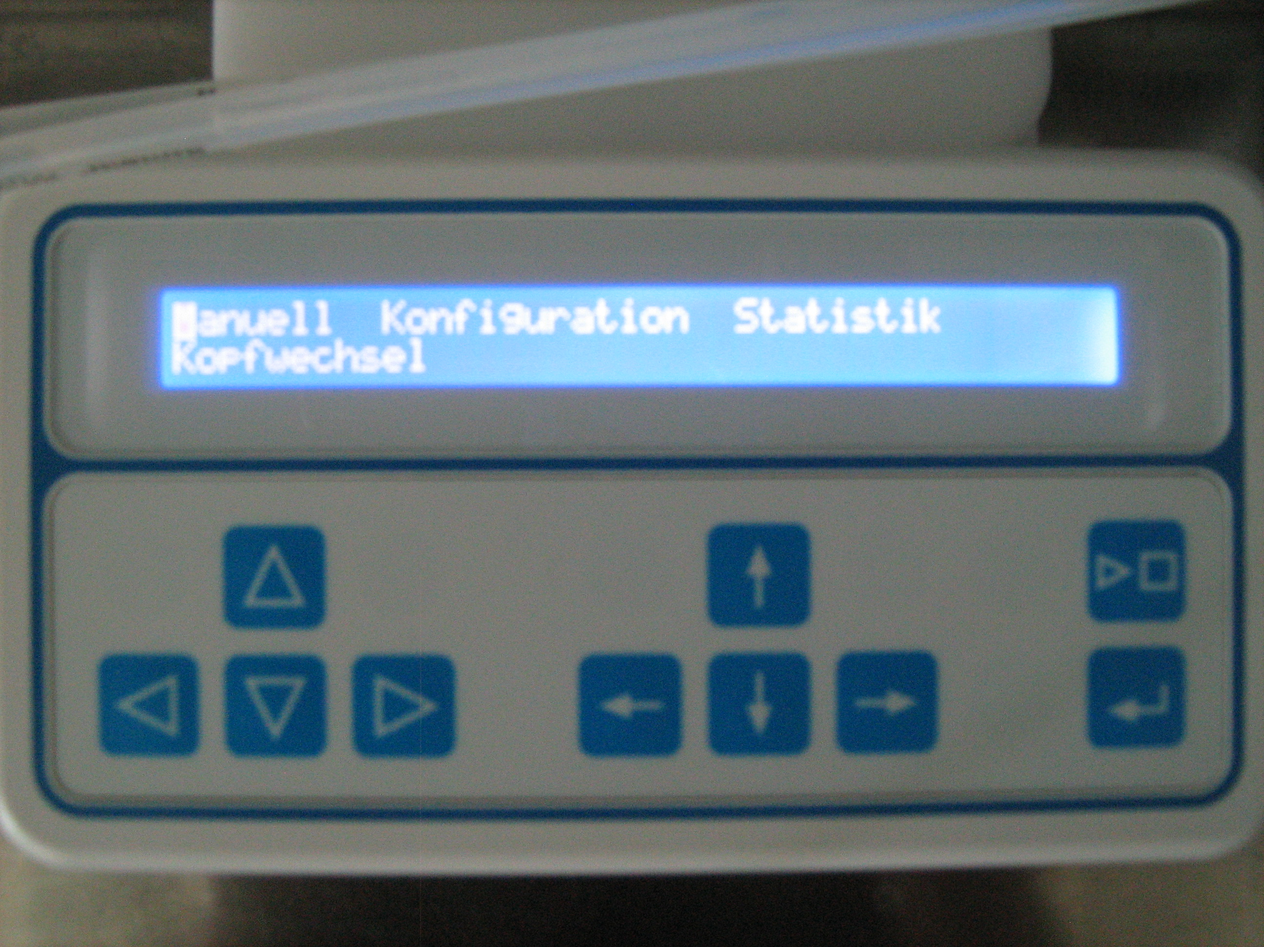*

Figure 4-5: *Cybiwell is ready to use*

1. Initialise stacker: push the left or right button at the stacker

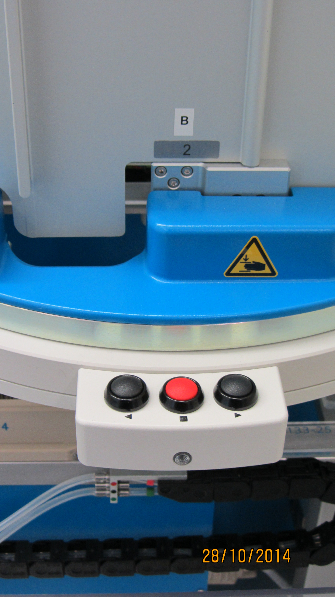

Figure 4-6: *Initialise stacker with the left or right button*

## 4.2 Prime Cybi-Well

**Notes:** Prime always Cybiwell before a method starts to fill the washstation tubings:

* Close the lever from the Masterflex pump 1 and 2 from relaxed to fixed.
* Check the correct tube position by streching the tube with your fingers.
* Check the VE-water bottle for enough water (2 or 3 liter left) or fill it up (max. 7,5 liter).
* Open the method: **Öffnen/User/DKFZ/Rinse-WS** and klick on the play button. Repeat this method until all 384 tubes build a small water dome.

**Note:** If Cybiwell was unused for more than a week, start the cleaning method with 80% Isopropanol or with 3% Sodiumhypochlorid to desinfect the tubings. Repeat this step with VE or Milliporewater to remove all cleaning reagents.

**Note:** If necessary rinse the wohle system with water, 80% Isopropanol or with 3% Sodiumhypochlorid. Open the method: **Öffnen/User/DKFZ/Rinse-System.** Repeat this step twice with VE or Milliporewater to remove all cleaning reagents.

### 4.3 Fix cells with Fix-Perm-solution

**Notes:**

* The Fix-Perm method runs with the refillable reservoir **RF1**.
* The incubation time is 1h.
* 700 ml Fix-Perm-solution for 40 plates

Necessary reagents:

* Milliporewater
* 1x PBS
* Fix-Perm-solution *(calculate a dead volume of 50 ml)*

Total time for 40 plates (approx.): Setup: 20min.; Method: 2h 20min

1. Open the method: **Öffnen/User/DKFZ/1\_PFA\_Cell\_Fixiation**
2. Replace the water bottle with the 1x PBS bottle *(source bottle)*
3. If necessary empty the Waste-bottle *(sink)*
4. Plug the refill-tube to the Fix-Perm-solution bottle and close the lever RF1
5. Remove seals or lids from the assay plates and put them in Stacker A. Start with one plate and stack the other plates on top *(dry any wet patches with a clean whipe)*
6. **Check:** - Fix-Perm solution is connected with the refill pump 3 (RF1)

* 1x PBS is connected with the source pump 1 (WS1)
* Waste/Drain pump 2 is connected with the waste-bottle (WS2)
* Stacker A door is closed
* Stacker B is empty
* Refill-reservoir is emtpy, clean and on position 1

1. Start the method by clicking on the play button, enter the number of assay plates, choose a well volume (not greater than 100 µl) and answer the question for pre-rinse with true *(for the following run, one can skip this feature and enter false)*.
2. The method is finished when a final infobox pops up *(confirm it with „ok“)*

### 4.4 Stain Cells with dye(s) & antibody

**Notes**:

* This method runs with both refillable reservoirs **RF1 & RF2**.
* The incubation time is 1h.
* Use max. 40 plates
* 1000 ml blocking buffer for 40 plates
* 300 ml stain solution for 40 plates
* Ice bucket for stain solution

Necessary reagents:

* Millipore water
* 1x PBS
* Blocking buffer *(calculate a dead volume of 50 ml)*
* Antibody/Dye mix in blocking buffer *(calculate a dead volume of 50 ml)*

Total Time for 40 plates (approx.): Setup: 20min.; Method: 3h 30min

1. Open the method: **Öffnen/User/DKFZ/2\_** **Add\_AntibodyDye-Reservoir**
2. Replace the Millipore bottle with the 1x PBS bottle *(source bottle)*
3. If necessary empty the Waste-bottle *(sink)*
4. Plug the refill-tube RF1 to the Blocking-solution bottle and the refill-tube RF2 to the staining bottle and close the levers
5. Remove seals or lids from the assay plates and put them in Stacker A. Start with one plate and stack the other plates on top
6. **Check:** - Blocking solution is connected to refill pump 3 (RF1)

* Staining solution is connected to refill pump 4 (RF2), bottle is on ice
* 1x PBS is connected with the source pump 1 (WS1)
* Waste/Drain pump 2 is connected with the waste-bottle (WS2)
* Stacker A door is closed
* Stacker B is empty

1. Start the method by clicking on the play button and enter number of assayplates, and answer the question for rinse with true or false.
2. The method is finished when a final infobox pops up *(confirm it with „ok“)*

### 4.5 Clean Cybi-Well

1. Remove all assay plates from Stacker B
2. Connect RF1 and RF2 with the dual olive bottle, filled with water *(it is not depent if RF2 was used or not)*
3. Open the lid of the dual olive bottle lightly, avoid vacuum
4. Change the source bottle for pump 1 with the VE-water bottle
5. Open the method: **Öffnen/User/DKFZ/Rinse-system** and klick on the play button. Repeat this method.
6. Clean the refillable reservoir with water and dry it with paper towels.
7. Release all pump lever to the relaxed position.
8. Empty the waste bottle!!! *(sink)*
9. Whenever liquid is spilled on the rail, adapter and other parts (white spots) wipe off with wet paper towels. Never use ethanol or an organic solvent!!!

### 4.6 Shut down Cybi-Well

**Note:** Shut the instrument down at the end of the day. There is no reason to leave Cybiwell powered on over night.

* Release tips (described in figure 4-7 to 4-9)
* Switch off the instrument by disconnecting of the powerboard from the electric supply
* Shut down PC and monitor



Figure 4-7: *Choose „Manuell“ (default) and press enter*

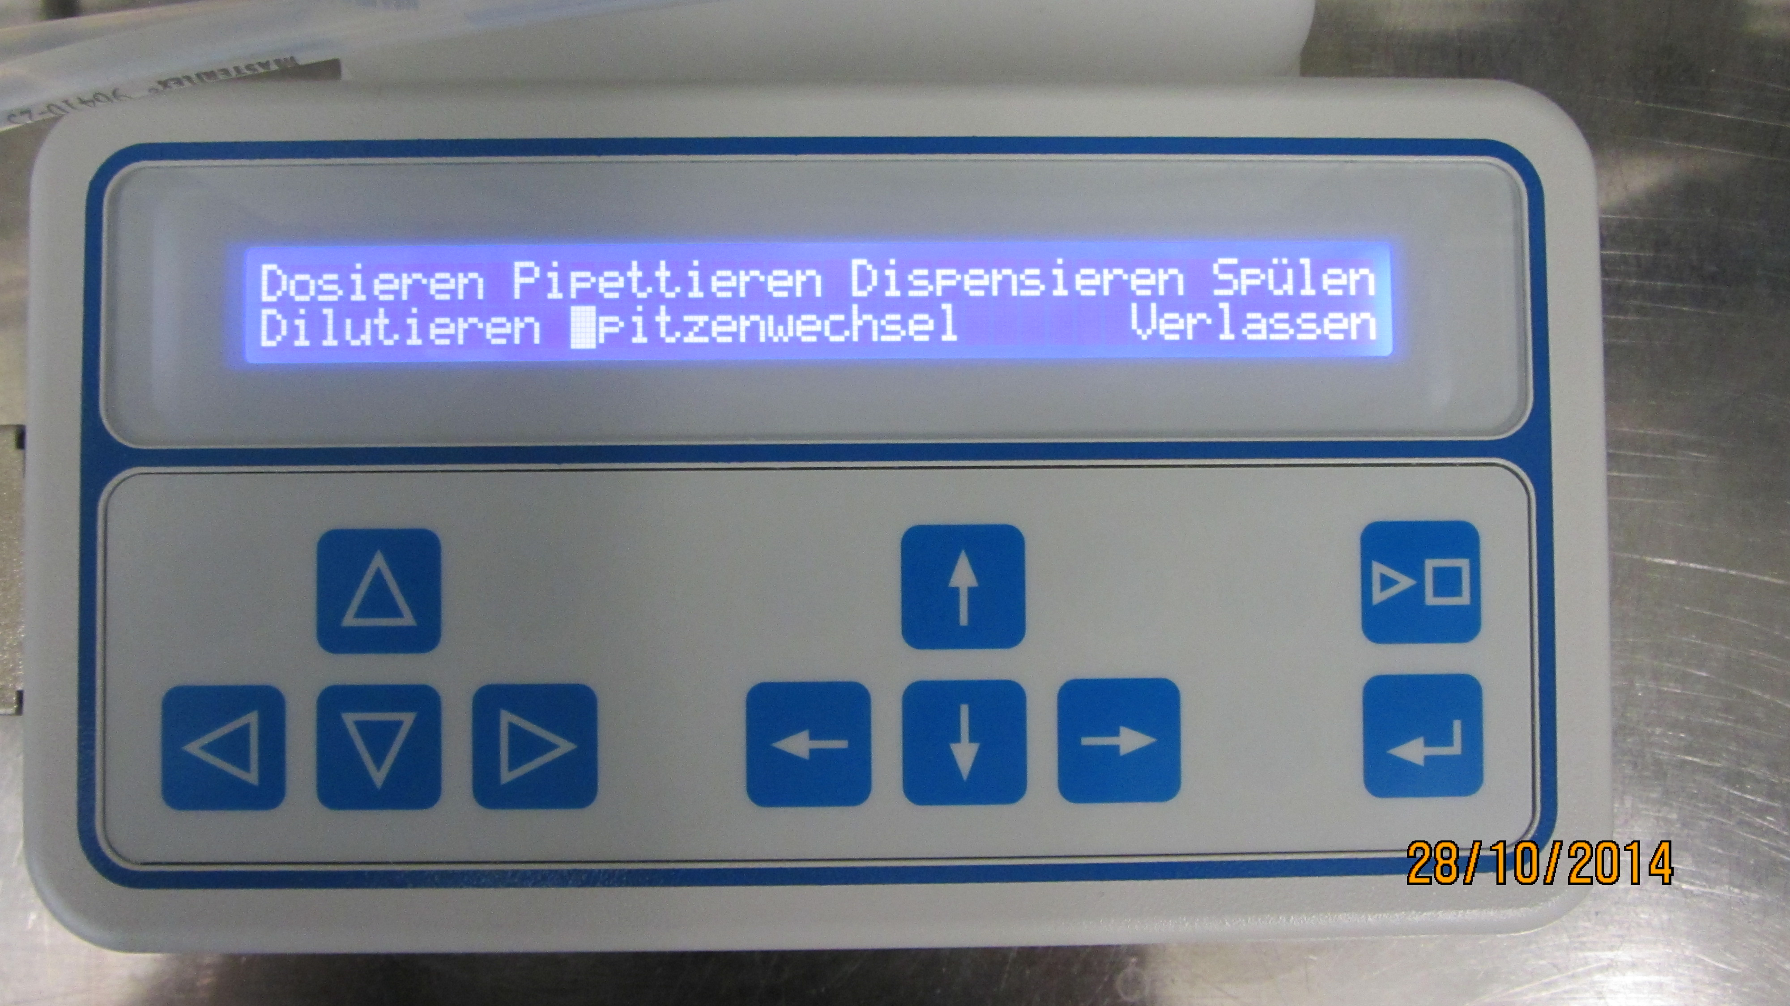

Figure 4-8: Use the arrow-keys to select „Spitzenwechsel“ and press enter

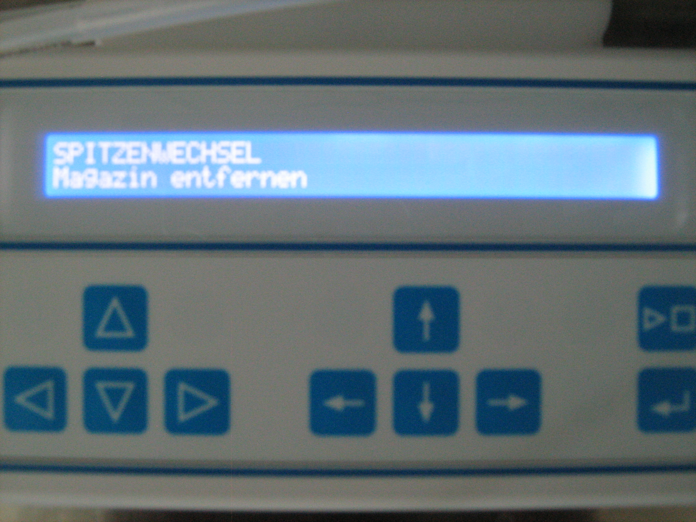

Figure 4-9: *Tips are released.*

# 5 Safety information

**General:**

The instrument is located under an exhaust hood without a light curtain. To avoid any injuries close **always** the hood and do not touch the running instrument. To interrupt an ongoing run, click on the „pause“ symbol and wait until the instrument has finished its last move.

**Instrument warnings:**

|  |  |  |
| --- | --- | --- |
| Caution | Meaning | Comment |
| Mavericks:Users:thilo:Desktop:elektrik.jpg | Caution of hazardous electrical voltage | Before removing a mechanical or electrical component, Cybi-well must be first switched off and disconnected from the main electricity supply.  Do not open the instrument. Only the technical service from Cybio has the knowledge to open the pipettor. |
| Mavericks:Users:thilo:Desktop:Handverletzung.png | Caution against hand injuries | Warning against bruise because of the moving parts like rail, lifter and stacker. |
| Mavericks:Users:thilo:Desktop:w25_.gif | Caution against automatic start | Depending on the method every part oft he instrument (could) perform a sudden movement. |

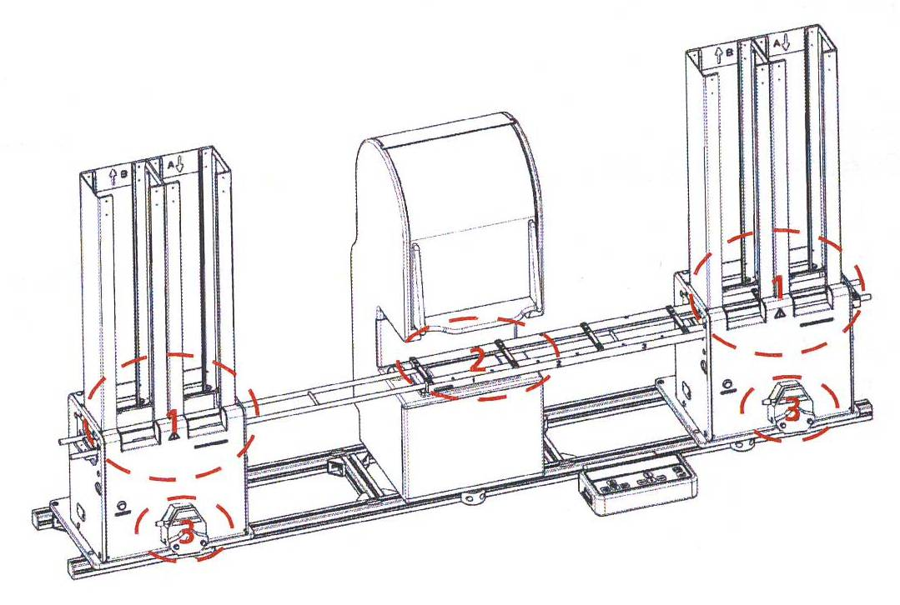**Critical areas:**

1. Stacker and lifter
2. Rail and lifter
3. pumps

Figure 5 – 1: *Accident risk in the space of moving parts*

# 6 Other applicable documents

More informations to Cybi-Well vario:

* Cybi-Well vario Bedienungsanleitung
* Cybi-QuadStack Bedienungsanleitung
* Cybio Composer Version 2.30 Scripting Bedienungsanleitung

# 7 Attachements

### 7.1 Buffer

* **1x PBS buffer, pH 7.4, 1l**

Dissolve 1 bag PBS powder in 1l milliporewater.

*Prepared 1x PBS can be stored in a cold room 4°C for several weeks.*

* **10x PBS buffer, pH 7.4 (6.8), 1l**

Dissolve the following in 800 ml millipore water:

80g of NaCl

2.0g of KCl

14.4g of Na2HPO4

2,4g of KH2PO4

Check pH value. It should be around pH 6.8

Adjust volume to 1l with additional millipore water.

Sterilize by autoclaving.

Desolve the 10x PBS buffer (1L) in Millipore water (9L), getting the 1x PBS buffer. Ph value should be around 7.4

### 7.3 Fix and blocking solution

* **Fix-Perm solution (4% PFA; 0,3% Triton X-100; 0,1% Tween20; 1% BSA), 1l**

Dissolve 40 g PFA in 500 ml 1x PBS. Cover the beaker with an alu foil and put it on a heat/stirrer. Stir with middle speed and 56°C until the solution becomes clear. Filtrate the solution with a Millipore steri-cup.

Dissolve 10 g BSA in 400 ml 1x PBS on a stirrer. Add 3 ml Triton X-100 and 1 ml Tween20. Let it stir until the solution becomes clear.

Mix both solutions and adjust to 1l with 1x PBS.

*The solution can be stored at 4°C for one week.*

* **Blocking solution (4% BSA; 0,1% Triton X-100, 0,1% Tween20), 1l**

Dissolve 40 g BSA in 800 ml 1x PBS on a stirrer. Add 1ml Triton X-100 and 1ml Tween20. Let it stir until the solution becomes clear. Adjust with 1x PBS to 1l.

*The solution can be stored at 4°C for one week.*

### 7.2 Stain solution

* **Hoechst 33342**

Dissolve 100 mg Hoechst with 10 ml Milliporewater (10 mg/ml)

Dilute the concentration 1:10 with Milliporewater (1 mg/ml)

*Aliquote the solution and store at -20°C.*

* **Phalloidin-TRITC**

Dissolve 1 mg with 1 ml DMSO (1 mg/ml)

*Aliquote the solution and store at -20°C.*

* **α-Tubulin-FITC**

The antibody solution is ready to use. If necessary aliquote the solution and store at -20°C

* **Antibody/Dye mix in the ERC project:**

200ml 300ml (in blocking buffer)

Hoechst 1:4000 50 µl 75 µl

Phalloidin 1:6000 34 µl 50 µl

α-Tubulin 1:1500 134 µl 200 µl

Calculate for 40 plates 300 ml (50 ml deadvolume Cybio).

### 7.3 Clean and desinfect reagents

* **80% Isopropanol, 2l**

Dilute 1600ml Isopropanol absolut with 400ml Millipore- or VE-water

* **3% Sodiumhypochlorid solution, 2l**

Dilute 500ml 12% Sodiumchlorid with 1500ml Millipore- or VE-water